Name: ______________________________ School: ___________________

Employability Skills Area: Workplace Effectiveness

Assignment Name: Glog It!!!

Throughout the course, you have been responsible for gathering information to enhance your workplace skills. From communication to ethics, leadership to professionalism, you should be more knowledgeable now than you were at the beginning of the year regarding your future as well as skills you need to be successful in both your college and career plans. Share your knowledge in a creative way by glogging it! Create an account at glogster.com and create a visual display of your “learning.” You can add video and audio files as well as links to enhance your Glog.
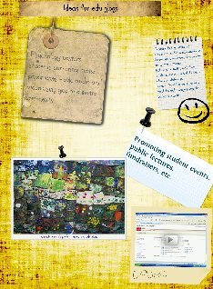
Share the finished Glog with your WBL Coordinator by following the instructions on the website for sharing the Glog via email which is found under the send to friends link on the Glogster page.

www.glogster.com

Glogster is really only limited by your creativity. So be sure to express your own style with your work.

Activity Rubric - here

