Name: _________________________

Employability Skills Area: Communications

Assignment Name: Inc. Magazine
Inc. Magazine offers a collection of communication-related articles designed to give quick and practical tips for improving communication skills. Click on the Inc. Magazine link below and select 5 articles to read.

http://www.inc.com/guides/growth/23032.html

Then complete the following information:
- Name of selected articles & authors (if available).

- Complete the Mindmap below: 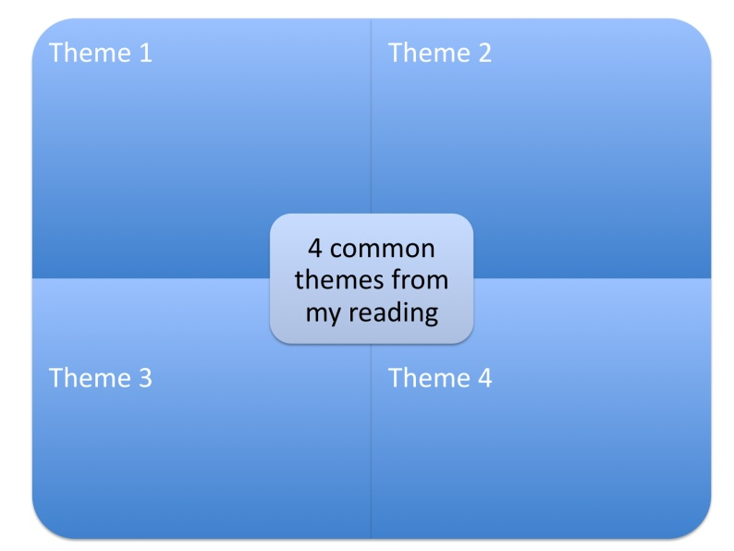

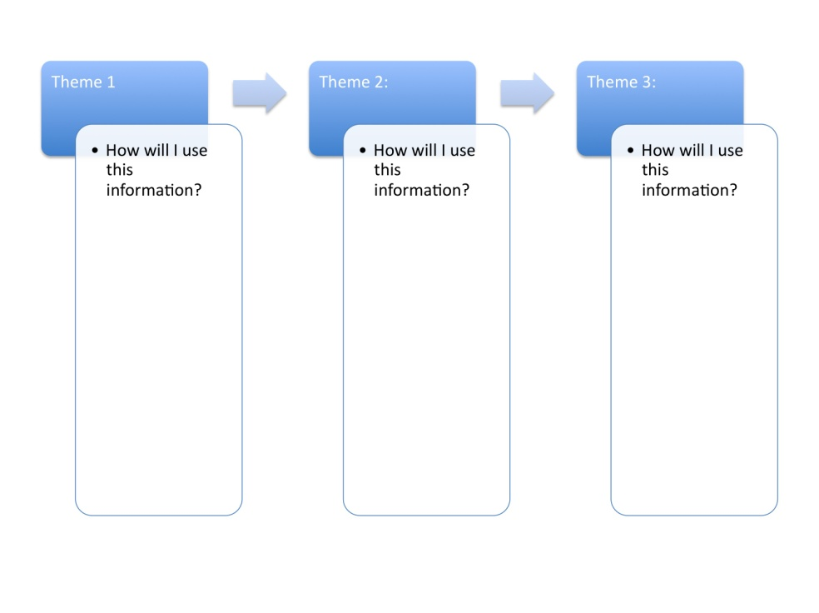
3. Select three of the themes listed above and complete the chart below:

