Name: ______________________________

Employability Skills Area: Problem Solving & Critical Thinking

Assignment Name: Your First Job was WHAT?
Your First Job was WHAT?

Students will conduct interviews to learn more about what people’s first jobs are like. Students will interview at least two people (family members or other adults) about their first jobs.

Students should prepare five questions before the interview. Possible questions can include:

- How old were you when you got your first job?
- What was it?
- What made you decide to get the job?
- What did you learn from it?

Students should fill in the five large circles on the bubble graphic organizer (see below) with the five interview questions and then fill in respondents’ answers to the questions in the small circles and squares that branch off of the large circles.

In order to keep the chart organized, students are to write all of the interview answers from one participant into the small squares and use the small circles for all of the answers from the other candidate.

After completing the interviews and graphic organizer, students are to create an expressive writing response detailing the skills, talents, or experiences they have that the interviewees use in their current career fields.

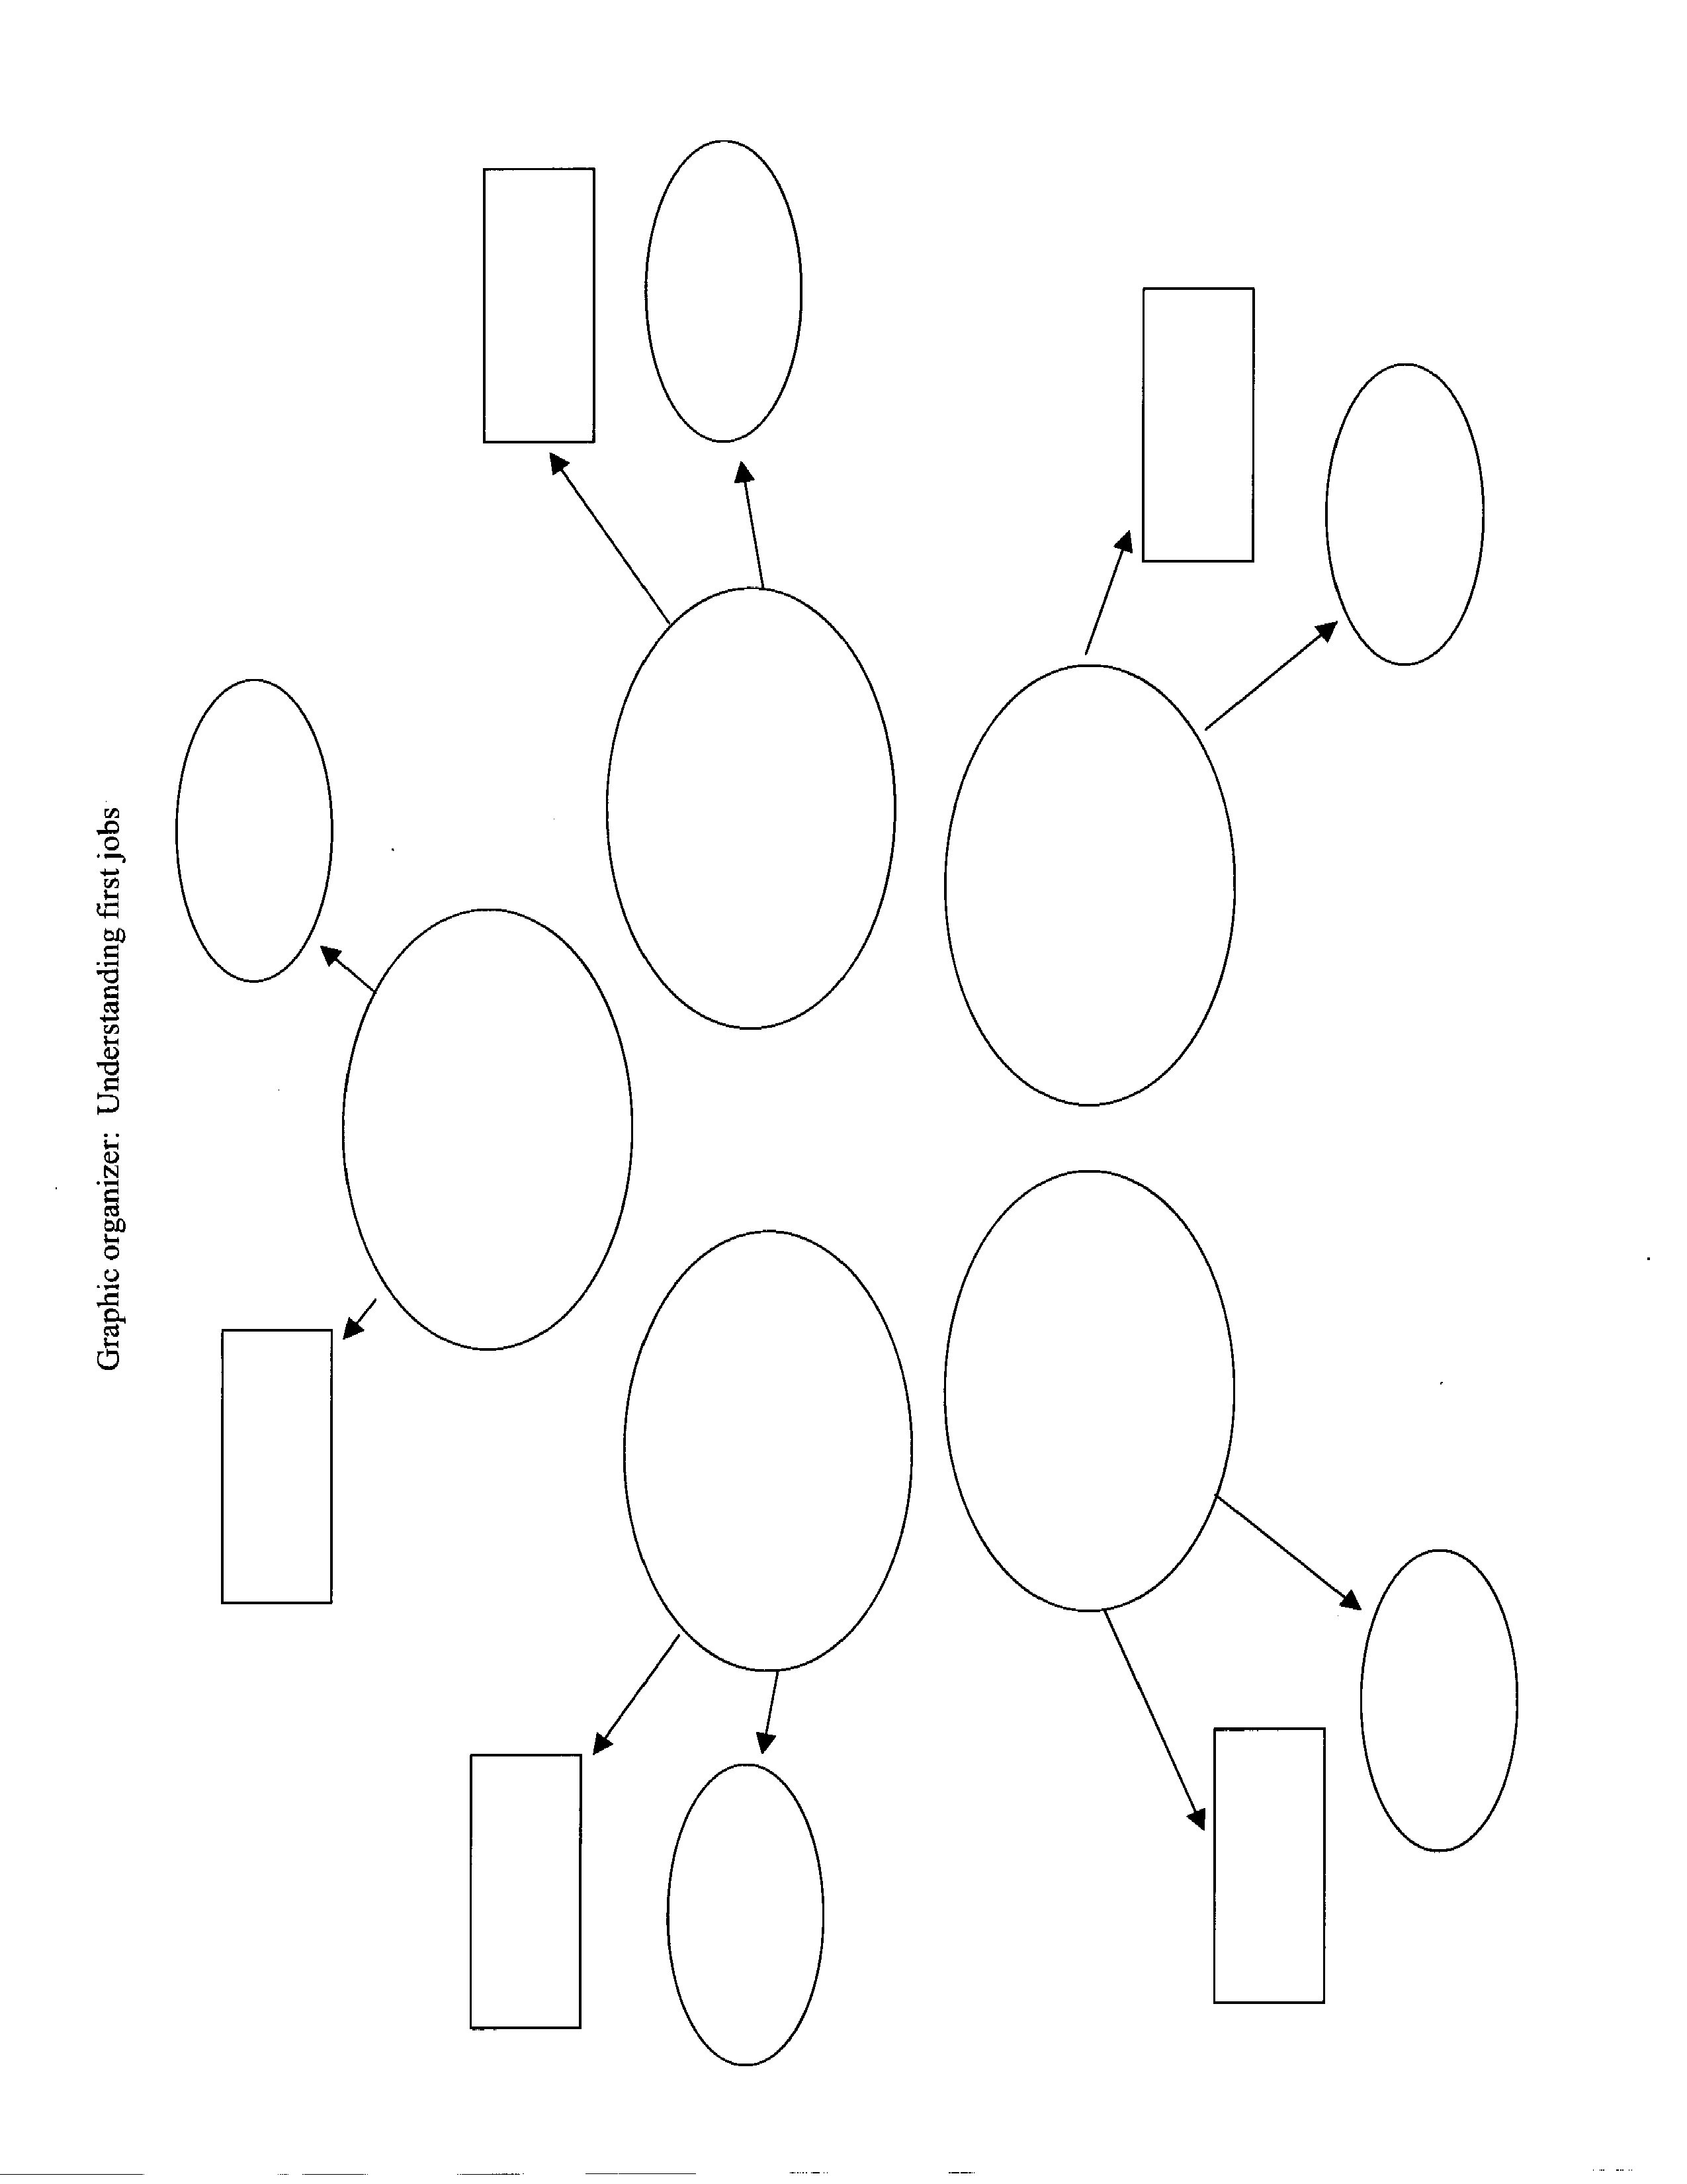
Click here to enter text.
Click here to enter text.
Click here to enter text.
Click here to enter text.
Click here to enter text.
Click here to enter text.
Click here to enter text.
Click here to enter text.
Click here to enter text.
Click here to enter text.
Click here to enter text.
Click here to enter text.
Click here to enter text.
Click here to enter text.
Click here to enter text.

